Research Infrastructures - Laboratories and Equipment at the University of Cyprus

Department of Civil and Environmental Engineering Strength of Materials Laboratory
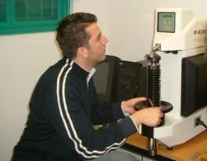
The objective of the Strength of Materials Laboratory is to support the relevant research and teaching needs of the faculty members of the Department of Civil and Environmental Engineering. The Laboratory is equipped with a 300 kN Materials Testing Machines, manual test stands, hardness testers, a torsion apparatus, microscopes, ovens, furnaces and equipment for the preparation of specimens.

Building Materials Laboratory
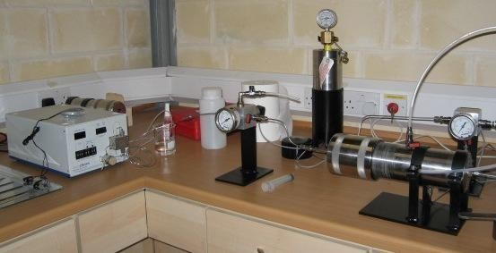

Laboratory fully equipped to EN Standards. Supports the research and teaching needs of the faculty members of the Department of Civil and Environmental Engineering, in the area of Geomaterials. Ongoing research activities in the laboratory include the design and application of lime mortars for restoration works, based on the characterization of ancient mortars, the analytical investigation of self-compacting concrete flow, the characterisation of local aggregates and stones and studies of liquid movement in porous media, with applications in the durability of building materials.

Laboratory of Environmental Engineering
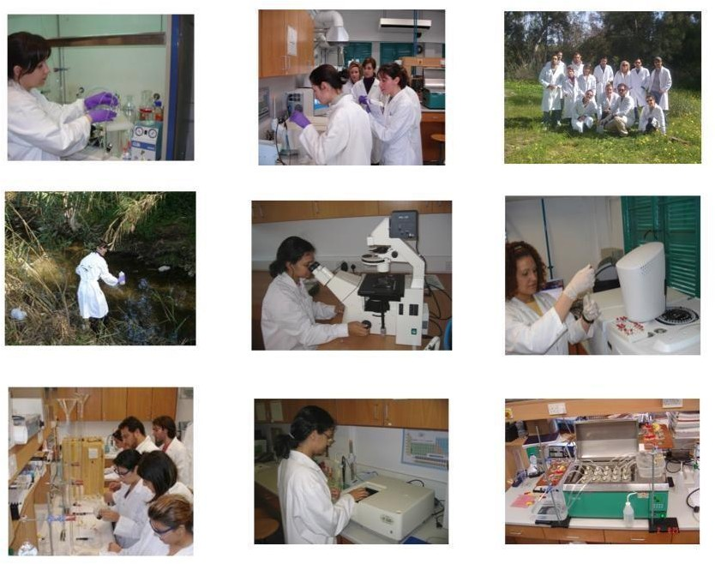
The Laboratory of Environmental Engineering, GAIA, supports the teaching and research needs of the Department in the areas of water and wastewater analysis and treatment.
Teaching activities:
- CEE 480- Labs: Experimental analysis related to the evaluation of water and wastewater quality characteristics
- CEE 585- Labs: Experimental methods in water / wastewater characterization and treatment
Research activities:
In the past, research on the effects of chemical pollution of the environment has focused almost exclusively on conventional "priority" pollutants. However, there have been growing concerns related to the hypothesis that various chemicals may exhibit endocrine disrupting effects. This is due to increased incidences of endocrine-related diseases in humans, including declining

male fertility, and more significantly, to adverse physiological effects observed in wildlife where cause and effect relationships are more evident. The research group of GAIA consisting of students and researchers with background in Chemistry, Biology, Chemical and Environmental Engineering works in the field of xenobiotics, i.e. pesticides and pharmaceuticals in waters and wastewaters and more specifically with their determination in nano-concentrations, the assessment of their toxicity, and the development and application of advanced oxidation methods for their degradation or mineralization. In addition other biological methods are developed for the treatment of various other streams.
Other ongoing research activities include the monitoring of environmental pollution by nonpoint pollution sources and the modeling of anaerobic co-digestion of animal waste and other industrial bio-waste.

Geomechanics Laboratory
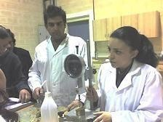
The Geomechanics Laboratory is equipped with a triaxial apparatus, a direct shear apparatus, consolidometers, constant and falling head permeameters, and all the necessary equipment for carrying out soil classification and compaction tests. The triaxial apparatus is capable of performing tests on partially saturated soil specimens by controlling matric suction through an advanced air pressure/volume controller. The laboratory serves the teaching and research needs of the Department of Civil and Environmental Engineering in the area geotechnical engineering.

Archimedes Research Center for Structural and Construction Technology
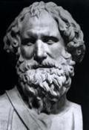
Archimedes Research Center for Structural and Construction Technology is an interdisciplinary research center for design, analysis and construction management of structures in the wider sectors of Civil Engineering and Architecture. The research center aims primarily at the development of specialized research, as well as its extension through interdisciplinary cooperation in the broader areas of Civil Engineering and Architecture.

The center was established in 2005 in the Faculty of Engineering of the University of Cyprus and conducts international research activities in structural and construction design (Marios C. Phocas), computer-aided structural analysis and information technology for Civil Engineering (Petros Komodromos) and construction engineering and management (Symeon Christodoulou). The projects analyzed in all research directions are not only of a general architectural identity but more so of major structural characteristics (such as multistorey, industrial buildings, sport facilities and bridges) and structural components (such as reinforced concrete, steel, light-weight and high strength composite materials).

Concrete Technology and Structures Laboratory
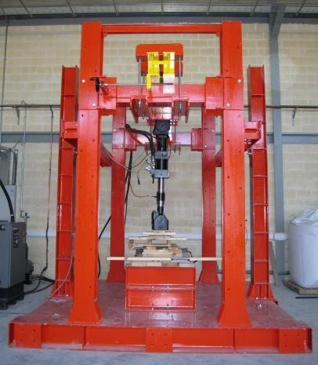
The two–story concrete technology and structural testing laboratory occupies 500 square meters. It is equipped with a 250kN MTS hydraulic actuator, digitally controlled and attached on a self–reacting steel frame. Large and small–scale structural components and structural systems can be tested under static and dynamic loading conditions using this apparatus. The laboratory is also equipped with mixers, concrete testing frames and equipment for the testing of self compacting concrete in the fresh state.

Environmental Fluid Mechanics Laboratory

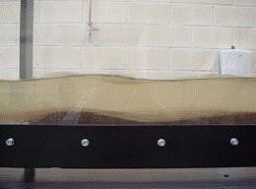

Environmental Fluid Mechanics Laboratory supports teaching and research needs of the CEE Department in the areas of urban air pollution dispersion, turbulence modeling, channel flows, buoyancy-driven flows/ gravity currents, building ventilation, wind engineering, and coastal flows.

Virtual Reality Laboratory
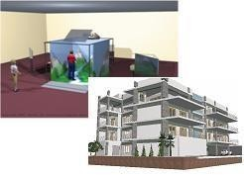
The virtual reality (VR) laboratory aims at the creation of a computing environment for visual representations, animations and simulations of engineering, architectural and construction management projects. The laboratory, which was partially funded by the Cyprus Research Promotion Foundation, holds a state–of–the–art CAVE environment and haptic peripherals, powerful workstations, 3D modelling and 4D simulation software.

Earthquake Engineering Laboratory
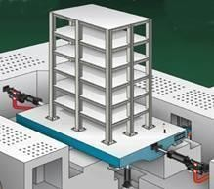

The socio-economic impact of a devastating earthquake can be felt in our region for years to come. Civil structures and infrastructure can become "killers" during a severe seismic event, unless they are properly designed, procured and constructed. The only sensible defense against major earth tremors is respecting design codes, aseismic techniques and quality construction practices, while advancing our knowledge and know-how on innovative aseismic
strategies.

The objective of the Earthquake Engineering Laboratory is to support research for improving the seismic behavior of engineered structures. The high-tech earthquake simulator (or shake table), key feature of the Earthquake Engineering Laboratory, is designed to accurately reproduce an earthquake event and, as such, is ideal for evaluating the performance of structures during earthquake conditions. Shake-table tests will enable researchers to examine and develop structural control strategies and other advanced technologies to improve the seismic performance of bridges, buildings and civil infrastructure.

Land Surveying Laboratory
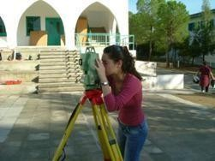
Laboratory equipped with Automatic Levels, Total Stations and a GPS. Used in the teaching of second semester course CEE 113 Land Surveying.

